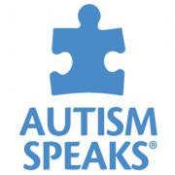
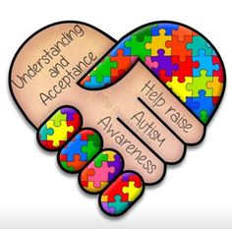
AUTISM AWARENESS
Invitational Track Meet
FRIDAY April 20th, 2018
North Shore High School
4:15 PM START

In recognition of Autism Awareness Month:
PROCEEDS WILL GO THE NASSAU-SUFFOLK AUTISM SOCIETY OF AMERICA

Cost: $175 entry AND a portion of the cost of the officials.
($300 for combined Girls and Boys teams)
We are looking for approximately 10-12 teams

PLEASE EMAIL INTENT TO ENTER ASAP + APPROXIMATE # OF ATHLETES
ENTRIES DUE BY MONDAY April 9th.
EMAIL: Neal Levy: levyn@northshoreschools.org or cell 516 330-4590
FAX: (516) 277-7042

4:15 Start (Rolling Schedule)
APPROX 6:00 PM-WE WILL A FEW 100m DASH “AUTISM AWARENESS” RACES
IF YOU HAVE ANY PARTICIPANTS-LET ME KNOW!!!!!

Order of Events (GIRLS FOLLOWED BY BOYS)
Girls 2k Steeple Chase/Boys 3k Steeple Chase
400 IH High Jump
100m Semi Long Jump
1500/1600 Triple Jump
100m Final Shot Put
400m Discus
100 HH/110HH Pole Vault
800m
200m
4 x 100
4 x 400
Awards: Medals to the top 5 competitors in each event.
Medals to the top 4 teams in each relay event
----------------------------------------------------------------------------------------------------------------

SCHOOL
COACH

COACH’S E-MAIL

PAYMENT $175 Payable to: NORTH SHORE SCHOOLS
Or 450 Glen Cove Ave
$300 Glen Head NY 11545
Attn: NEAL LEVY

